 | Ray D. Anderson
 | Court Residential Treatment Center
 | 613 E. Bynum Lane | Tel (806) 637-6677
 | Brownfield, TX 79316

Ray D. Anderson, CRTC Referral Form

Date: ________________________________ Expected Intake Date: _________________________
CSO Name: ___________________________________ CSCD/County: _______________________
CSO Phone #: __________________________________ Judge Name: _______________________
CSO Email Address: ________________________________________________________________

Defendant Information

Defendant Name: __________________________________________________________________
Age: ____________ Date of Birth: ____________________ Race/Sex: _______________________
Height: _____________ Weight: _________________ Hair: _____________ Eyes: ______________
Place of Birth: ________________________________________________ U.S. Citizen: Yes No
DL #: _________________________ State: __________________ Expired/Suspended: Yes No
Social Security #: ________________________ SID #: _____________________________________
OID #: _________________________________ PID #: ____________________________________
FBI #: ________________________________ Supervision Level: ____________________________

Offense Information

Current Offense: __________________________________________Cause #: _________________
Sentence Date: ______________________ Type of Probation: ______________________________
Incarceration Length: __________________ Supervision Length: ___________________ (Years/Months)
Extension: ________________ Expiration Date: ___________________ CSR Hours: _____________
Date of Offense: _________________________ Arrest Date: _______________________________
TRN #: ____________________________________ TRS #: ________________________________
Weapon Involved: Yes No If yes, please explain: ____________________________________
________________________________________________________________________________
Reason for referral: ________________________________________________________________
Prior Sanctions: ___________________________________________________________________
Terms/Conditions of Community Supervision Not Yet Completed: ____________________________
________________________________________________________________________________

Criminal History

Prior Criminal History: ______________________________________________________________
________________________________________________________________________________
Assaultive History: Yes No If yes, please explain: ____________________________________
________________________________________________________________________________
Charges Pending/Outstanding Warrants/Traffic Ticket(s): Yes No
If yes, please explain: _______________________________________________________________
________________________________________________________________________________
Currently on probation/parole for any other offense(s): Yes No
If yes, please explain: _______________________________________________________________
________________________________________________________________________________

Education

Highest Education Completed: _____________ Diploma or GED? Yes No
Literate: Yes No English Speaking: Yes No

Substance Use

Please indicate any history of substance use: ____________________________________________
________________________________________________________________________________________________________________________________________________________________
Drug(s) of choice: _________________________________________________________________
Last time drugs and/or alcohol used: ___________________________________________________
Date/Results of most recent drug/alcohol screening: _______________________________________

Should any defendant arrive at the Ray D. Anderson, CRTC under the influence of alcohol and/or drugs of any kind, and/or our drug tests indicate recent drug use to where a defendant is visibly disoriented, the defendant will be denied entry into the CRTC.

Employment

Is the defendant employable: Yes No If not, please explain: ________________________
________________________________________________________________________________
Is the defendant currently employed: Yes No If yes, please list company name and job duties: ___________________________________________________________________________
________________________________________________________________________________
Please list defendant's work history: ___________________________________________________
________________________________________________________________________________

Family Resources

Please include information of the nearest relative(s) of defendant.

Name: ____________________________________ Phone: ________________________________
Address: _________________________________________________________________________
City State Zip Code
Relationship to Defendant: ___________________________________________________________

Name: ____________________________________ Phone: ________________________________
Address: _________________________________________________________________________
City State Zip Code
Relationship to Defendant: ___________________________________________________________

Comments: _______________________________________________________________________
________________________________________________________________________________________________________________________________________________________________
Additional Information

Please include any other important information regarding the defendant that may be helpful to treatment staff:____________________________________________________________________________
________________________________________________________________________________________________________________________________________________________________________________________________________________________________________________________________________________________________________________________________

Required Documents for Placement Consideration & Acceptance

The following documents are required to be submitted to our facility for defendant's consideration and acceptance into the Ray D. Anderson, CRTC treatment program. Failure to provide these documents may result in a delay or denial of a defendant's acceptance into the program.

- Offense Report(s)
- Original Judgment(s) Placing Defendant on Probation
- Order(s) Modifying Conditions of Community Supervision (Including Extensions)
- Intra-State Transmittal(s)
- CRTC Referral Form
- CRTC Admission Health Screen (Including TB Testing and Results)
- Nine (9) Month Acknowledgment Form
- Texas Uniform Health Status Update (TUHSU) Form*
- Driver's License/Identification Card*
- Social Security Card*
- High School Diploma/GED*
- Medical/Dental/Vision Insurance Card*
- Assessments/Screenings/Evaluations*
- Active Protective Orders*
- Any other relevant documentation that may assist in treatment of defendant.

*-indicates only if applicable to defendant.

Area of page intentionally left blank.

End of CRTC Referral Form
TEXAS UNIFORM HEALTH STATUS UPDATE
This form MUST accompany all offenders transferred to and from all Texas criminal justice entities.
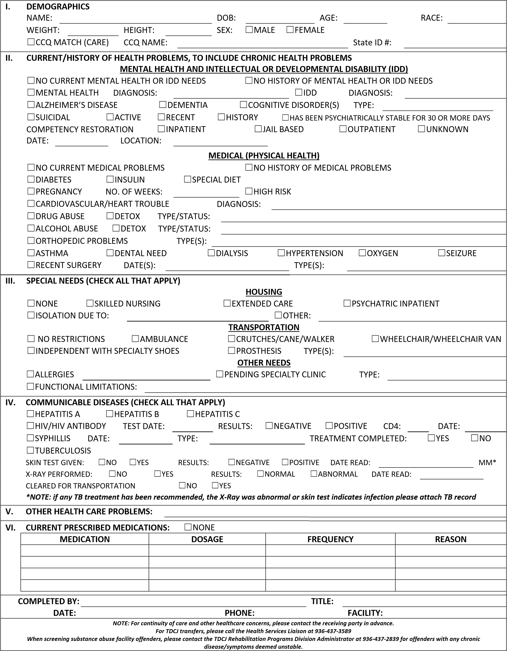

INSTRUCTIONS FOR TUHSU

This form MUST accompany all offenders transferred to and from all Texas criminal justice entities.

For the purposes of this form, the term “diagnosis” refers to a written diagnosis from a physician or licensed professional qualified to make a diagnosis.

- Demographics:
  - Print the inmate/patient’s name, date of birth (DOB), age, race, weight and height.
  - Place a check mark next to the appropriate label for sex.
  - Select CCQ Match if there is a record of the inmate/patient in the cross‐referenced MH/MR database (CARE); CCQ Name, print the inmate/patient’s name from the CARE database if different from the booking/conviction name.
  - Print the inmate/patient’s State Identification (SID) number.

- Current/History of Health Problems, including Chronic Health Problems (Check all that apply)
a. Mental Health and Intellectual or Developmental Disability (IDD)
    - Select No Current Mental Health or IDD Needs, if applicable.
    - Select No History of Mental Health or IDD Needs, if applicable.
    - Select Mental Health, if the inmate/patient currently has or has had a mental health diagnosis; print the diagnosis.
    - Select IDD, if the inmate/patient currently has or has had an intellectual or developmental disability; print the diagnosis.
    - Select Alzheimer’s disease, if applicable; print the diagnosis.
    - Select Dementia, if applicable; print the diagnosis.
    - Select Cognitive Disorder(s), if applicable and indicate the type; print the diagnosis.
b. Select Suicidal, if the inmate/patient has expressed suicidal thoughts or attempted suicide.
i. Select Active, Recent or History to provide framework for receiving facility’s knowledge about the inmate/patient.
    - Select PSYCHIATRICALLY STABLE FOR 30 OR MORE DAYS, if the inmate/patient has been stabilized in their mental health symptoms for more than 30‐days. Example: Inmate/patient has not been on suicide watch/observation or committed to mental health inpatient care within the past 30‐days.
    - Select Inpatient, Jail Based, Outpatient or Unknown; if the inmate/patient is or has participated in any of the listed applicable Competency Restoration programs. Print any known available dates and corresponding location of Competency Restoration occurrence. c. Medical (Physical Health)
- Select No Current Medical Problems, if applicable.
- Select No History of Medical Problems, if applicable.
- Select Diabetes, if the inmate/patient has a diagnosis.
        - Select Insulin, if the inmate/patient requires insulin for management of diabetic symptoms.
        - Select Special Diet, if the inmate/patient requires a special diet for management of diabetic symptoms (may be selected independently of selection of Insulin).
vii. Select Pregnancy, if the inmate/patient is currently pregnant; and confirmed with a test; print the number of weeks of gestation; print unknown if number of weeks is not known.
1. Select High Risk, if the pregnancy is considered high risk.
- Select Cardiovascular/Heart Trouble, if the inmate/patient has or has a history of coronary artery disease (CAD), heart attack, angina pectoris and/or congestive heart failure; print diagnosis.
- Select Drug Abuse, if the inmate/patient is currently or has a history of substance abuse treatment.
1. Select Detox, if the inmate/patient is currently or has recently been in detox; print current status of inmate/patient’s detox, Example: Active Withdrawal Symptoms.
x. Select Alcohol Abuse, if the inmate/patient is currently or has a history of alcohol abuse treatment.
1. Select Detox, if the inmate/patient is currently or has recently been in detox; print current status of inmate/patient’s detox, Example: Active Withdrawal Symptoms.
- Select Orthopedic Problems, if the inmate/patient has or has had chronic joint complaints or recent/current fractured or broken bones; print the types of complaints or locations of fracture or break.
- Select Asthma, if the inmate/patient has been diagnosed as a result of sudden attack shortness of breath accompanied by wheezing, caused by spasm of the airway or swelling of the airway.
- Select Dental Need, if there are any current dental problems the inmate/patient claims need attention.
- Select Dialysis, if the inmate/patient is on dialysis and receiving treatment.
- Select Hypertension, if the inmate/patient is currently being treated with medications or diet.
- Select Oxygen, if the inmate/patient requires current use of an oxygen tank continuously or as needed (supplemental) and/or uses a CPAP machine.
- Select Seizure, if the inmate/patient has or has had current or history of seizures.
- Select Recent Surgery, if the inmate/patient has undergone a recent surgery; print the date or dates of the event and indicate the type of surgery or reason for surgery.

- Special Needs (Check all that apply)
a. Housing
    - Select None, if the inmate/patient does not currently require any specialized housing due to a physical or mental health concern, Example: the offender is eligible for general population with no special accommodations.
    - Select Skilled Nursing, if the inmate/patient has a temporary problem requiring inpatient nursing care.
    - Select Extended Care, if the inmate/patient has a permanent condition requiring long‐term inpatient nursing care.
    - Select Psychiatric Inpatient, if the inmate/patient is in need of crisis management or is currently participating in inpatient‐level psychiatric care.
    - Select Isolation due to, if the inmate/patient is currently or needs to be in isolation due to a health problem. Example: active Tuberculosis, Chicken Pox or Measles; print the reason for the isolation.
    - vi. Select Other, if the inmate/patient has a current need for specialized housing due to the medical and or mental health problem and print description of housing need/type.
b. Transportation
    - Select No Restrictions, if the inmate/patient is able to independently walk greater than 25‐yards and/or requires no assistance or assistive devices to move about.
    - Select Ambulance, if the inmate/patient requires an ambulance to transport between facilities.
    - Select Crutches/Cane/Walker, if the inmate/patient needs or utilizes crutches, a cane or a walker to move around.
    - Select Wheelchair/Wheelchair Van, if the inmate/patient requires or needs a wheelchair to move distances greater than 25‐years and/or requires a wheelchair accessible van for transport between facilities.
    - Select Independent with Specialty Shoes, if the inmate/patient is able to walk distances greater than 25‐yards on their own if using specialty footwear.
    - Select Prosthesis, if the inmate/patient has a prosthesis; print a description.
c. Other Needs
    - Select Allergies, if the inmate/patient has any known allergies; print description of all that apply.
    - Select Pending Specialty Clinic, if the inmate/patient has a pending specialty clinic appointment or need; print a description of the type of specialty clinic and location, Example: Oncology chemotherapy at local hospital.
    - Select Functional Limitations, if the inmate/patient is unable, needs assistance or needs prompting to accomplish Activities of Daily Living (ADL); Example: can the inmate/patient eat, bathe, dress, toilet and/or move about independently? If not, to what degree is assistance needed; print description.

- Communicable Diseases
  - Select Hepatitis A, Hepatitis B, or Hepatitis C, if the inmate/patient has an active infection.
  - Select HIV/HIV Antibody, if the inmate/patient is suspected of having or has; print the test date and select the results (Negative or Positive) and print the last known CD4 count and Date, as applicable.
  - Select Syphilis, if the inmate/patient is suspected of having or has; print the date of diagnosis/testing and type; select treatment completion status (Yes or No).
  - Select Tuberculosis, if the inmate/patient is suspected of having or has a tuberculosis history.
    - Select No or Yes, if a skin test was completed.
    - Select Negative or Positive, skin‐test result outcomes; print the date the test was read; print the MM* or reaction, if no reaction print 0.
    - Select No or Yes, whether an X‐Ray was performed.
    - Select Negative or Positive, X‐Ray result outcomes; print the date of the reading.
    - Select No or Yes, if the inmate/patient is cleared for transport

- Other Health Care Problems
a. Print any additional conditions the inmate/patient has that might indicate need of medical care, Example: body deformities, swelling, open wounds, skin discoloration, rashes, needle marks, severe dental problems, etc.

- Current Prescribed Medications
  - Select None, if the inmate/patient is not currently prescribed medications.
  - If the inmate/patient is prescribed medications complete areas of the table fully with, name of Medication, prescribed Dosage, prescribed administration Frequency, and Reason the inmate/patient is on the medication.

Upon completion of the form, fill out the following fields legibly: Completed by, Title, Date, Phone, and Facility.

Area of page intentionally left blank.

End of Texas Uniform Health Status Update form.

 | Ray D. Anderson
 | Court Residential Treatment Center
 | 613 E. Bynum Lane | Tel (806) 637-6677
 | Brownfield, TX 79316

Admission Health Screening Form

Today's Date: _______________ Time: _______ AM PM Admission Date: ________________

Defendant Information

Defendant Name: __________________________________ SID #: __________________________
Age: ____________ Date of Birth: ____________________ Race/Sex: _______________________
Height: _____________ Weight: _________________ Hair: _____________ Eyes: ______________
Recent unplanned weight loss: Yes No Recent unplanned weight gain: Yes No
If yes, how much weight in what length of time: ___________________________________________

Vitals

Blood Pressure Reading: __________/____________ Temperature Reading: ___________________
Pulse Reading: _____________________________ Respirations Reading: _____________________

Allergies

Drug Allergies: ____________________________ Reaction: _______________________________
Food Allergies: ____________________________ Reaction: _______________________________
Environmental: ____________________________ Reaction: _______________________________
(Cedar, mold, etc.)

Tuberculosis (TB) Screening
TB skin test is to be administered and read within seven (7) calendar days
prior to admission or after admission to facility.

Date Administered: _________________ Date of Reading: _________________ Results: ______mm.
If past history of previous positive TB skin test, provide date and results: ________________________
________________________________________________________________________________
TB Symptoms Screening Questionnaire Completed: Yes No Date: ____________________
Symptomatic: Yes No If yes, referred for medical evaluation: __________________________
Chest X-Rays (only if applicable): Date: _____________ Results: ____________________________
Recommendations (if any): __________________________________________________________
________________________________________________________________________________
Continued on next page
Medication History

List all prescription drugs and over-the-counter drugs currently being taken including herbal preparations, vitamins and other supplements.

Medication | Dosage | Frequency/Instructions | Reason Taken | Last Time Taken

Family Medical History

Does anyone in your family have a history of any of the following?

Health Problem | Yes | No | Who?  (Mother, Father, Sibling, Grandparent)
Alcoholism
Arthritis
Cancer
Bleeding Disorder
Diabetes
Drug Addiction
Heart Disease
Epilepsy/Seizures
High Blood Pressure
Kidney Disease
Mental Illness
Mental Retardation
Stroke
Thyroid Disease

Past Medical History: (accident, injury, major hospitalizations, surgery): _______________________
________________________________________________________________________________________________________________________________________________________________________________________________________________________________________________
Last Tetanus Immunization: _________________ Recent accident/injury/surgery: _______________
If yes, please explain: _______________________________________________________________
Continued on next page
Do you now have, or have you ever been told you have any of the following problems?

 | Yes | No |  | Yes | No |  | Yes | No |  | Yes | No
Alcoholism |  |  | Swelling of Ankles/Legs |  |  | Syphilis |  |  | Drug Abuse
Allergies |  |  | Gout |  |  | Gonorrhea |  |  | Seizures
Anemia |  |  | Cancer |  |  | Herpes |  |  | Stroke
Asthma |  |  | Diabetes |  |  | Other STIs |  |  | Slurred Speech
Bronchitis |  |  | Thyroid Disease |  |  | Broken Bones |  |  | Numbness
Chronic Cough |  |  | Kidney Disease |  |  | Back Problems |  |  | Paralysis
Frequent Colds |  |  | Gallbladder |  |  | Dentures |  |  | Dizziness
Hay Fever |  |  | Heartburn |  |  | Hearing Loss  L/R Ear |  |  | Fainting
Shortness of Breath |  |  | Gastrointestinal Ulcers |  |  | Hearing Aid |  |  | Headaches  Frequent/Severe
Sinusitis |  |  | Nausea |  |  | Eye Glasses |  |  | Males
Emphysema |  |  | Vomiting |  |  | Contact Lenses |  |  | Prostate Problem
Tuberculosis |  |  | Sickle Cell |  |  | Glaucoma |  |  | Females Only
Pneumonia |  |  | Hepatitis |  |  | Cataracts |  |  | Pregnant
Wheezing |  |  | Arthritis |  |  | High Blood Pressure |  |  | Last Menstrual Cycle | Date:
Coughing Up Blood |  |  | High Cholesterol |  |  | Hemorrhoids |  |  | Missing Periods
Chest Pain |  |  | Hernia |  |  | Constipation |  |  | Last Pap Smear
Heart Disease |  |  | Varicose Veins |  |  | Diarrhea |  |  | Last Breast Exam
Heart Murmur |  |  | Leg Cramps |  |  | Blood in Stool |  |  | Post-Menopausal
Pace Maker |  |  | Vascular Disease

If you answered yes to any of the questions above, please explain: _______________________________________________________
____________________________________________________________________________________________________________
Are there any other health problems not included in the list above? ________________________________________________________
____________________________________________________________________________________________________________
Family physician's information if applicable: __________________________________________________________________________
Dental problems: (any current dental problems that require immediate attention):_____________________________________________
____________________________________________________________________________________________________________

Continued on next page
Mental illness current or past history: (any history of suicide attempts or ideation): Yes No
If yes, please explain: ________________________________________________________________
Are you currently having any thoughts of harming yourself or others? Yes No
Have you ever received treatment for mental illness? Yes No
If yes, when and where? ______________________________________________________________

Have you ever been diagnosed with any of the following? Yes No
(Please check all that apply)

Attention Deficit Disorder Eating Disorder Schizophrenia
Anxiety Disorder Hyperactivity Disorder Sleep Disorders
Bipolar Disorder Memory Loss Other: ________________________
Compulsive Disorder Mental Retardation
Depression Panic Attacks

Are you currently receiving mental health services? Yes No
Attending psychiatrist: ______________________________ Phone: ___________________________
Date of Last Psychiatrist Visit: _________________________________________________________

Do you smoke or use other tobacco products? Yes No
If yes, what type? ______________________ Length of time: ________________________________
Amount used on a daily basis: _________________________________________________________
Attempted to stop use? Yes No If yes, when? ________________________________
Comments: ________________________________________________________________________
Alcohol and Drug Use/Abuse History: Inquire about the use of various types of alcohol (beer, wine, and liquor), illicit drugs, inhalants, prescription drugs, over-the-counter drugs of abuse, and any other drugs not mentioned.
Type of Alcohol/Drugs | Mode of Use  (IV, smoke, oral, etc.) | Amount Used | Frequency  of Use | Problems After Stopping Use | Last Date Used
Continued on next page
General observations:

- Behavior which includes state of consciousness, mental status, appearance, conduct, tremors and sweating: _______________________________________________________________________
_______________________________________________________________________________
- Body deformities, ease of movement, limited range of motion, assistive devices required: ______________________________________________________________________________________________________________________________________________________________
- Conditions of skin, including trauma markings, bruises, lesions, open sores, jaundice (yellow), skin rashes, infestations of the skin (lice, scabies, etc.), and needle marks or tracks, or other indications of drugs use: ____________________________________________________________________
_______________________________________________________________________________
_______________________________________________________________________________
- Special skin markings (tattoos, body piercing, etc.) _______________________________________
______________________________________________________________________________________________________________________________________________________________

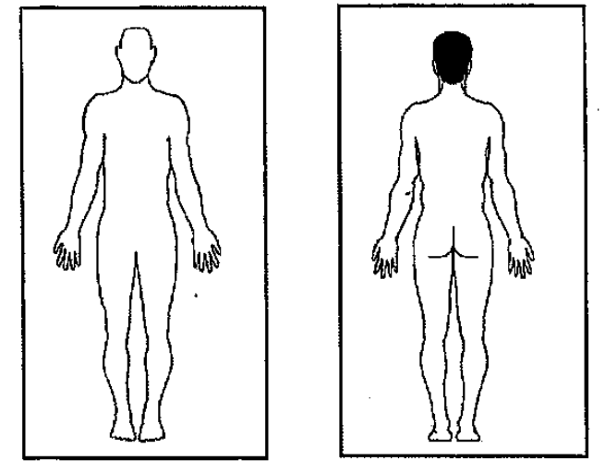

Codes for Body Outline:

A – Abrasions B – Bruises C – Cut L – Laceration P – Piercing R – Rash T – Tattoo S – Scar
N – Needle marks/tracks BR – Burn O – Open Sore ST – Stitches
Continued on next page
Regular Diet: Yes No Special Dietary Needs: _____________________________________
_________________________________________________________________________________
Activity Level: Total Limited Physical Restrictions: _______________________________
_________________________________________________________________________________
Lower Bunk Required: Yes No Cleared for Kitchen Duty: Yes No

Recommendations (if any): ___________________________________________________________
___________________________________________________________________________________________________________________________________________________________________________________________________________________________________________________

________________________________
Printed Name & Title
(Physician, PA, NP, RN, LVN, EMT-P)

________________________________ __________________________
Signature & Title Date
(Physician, PA, NP, RN, LVN, EMT-P)

I verify that the information that I have provided regarding my past medical history and current medical problems are correct to the best of my knowledge, and I authorize this information to be released to the Ray D. Anderson, CRTC treatment program.

________________________________
Defendant Printed Name

________________________________ __________________________
Defendant's Signature Date

End of Admission Health Screening Form
 | Ray D. Anderson
 | Court Residential Treatment Center
 | 613 E. Bynum Lane | Tel (806) 637-6677
 | Brownfield, TX 79316

RAY D. ANDERSON, CRTC
PROBATIONER ACKNOWLEDGMENT FORM

Please be advised that, prior to a probationer’s official acceptance into the CRTC treatment program, this form must be reviewed, signed and submitted to the CRTC.

- The Ray D. Anderson Court Residential Treatment Center (CRTC) treatment program will take a minimum of nine (9) months to successfully complete; however, if there are disciplinary issues with the probationer and/or recommendations for an extension made by the Director and/or the Treatment Team, this may result in an extension in the program.

- Potential CRTC residents must be functionally literate in English, in both verbal and written communication.

- Residents who leave the premises of the CRTC without approval from the Director and/or designated staff, and who do not return to the premises by the expected time as required by the Director and/or designated staff, are alleged to have committed the offense of Unauthorized Absence from a Correctional Facility, in accordance with Texas Penal Code Sec. 38.113. In the event that this occurs, a report will be submitted to the Brownfield Police Department so that, if appropriate, charges may be filed with the Terry County Attorney’s Office.

- Probationers accepted into the program will be ineligible for employment for a minimum of twenty-two (22) weeks after their acceptance date into the CRTC.

- The CRTC is unable to respond to major medical, dental and/or vision needs of a probationer. Outside providers will handle any medical, dental and/or vision needs of the probationer. The probationer must pay any cost(s) associated with these services. If the probationer has medical, dental and/or vision insurance, a copy of the insurance card must be provided to our office prior to the probationer’s admission into the program.

- The CRTC must be notified of all prescription medication(s) that the probationer is currently taking, and said probationer must be in compliance with said prescription(s) prior to the probationer’s admission to the CRTC program.

By my signature below, I hereby acknowledge that I have received the information above and that I have read and reviewed this information in the presence of my supervision officer.

___________________________ __________________
Probationer Signature Date

___________________________ __________________
Supervision Officer Signature Date

